**Practice problem sets**

1. **NullPointerException**

Create a Java class **Person** with attributes **name** and **age**. Then, create a method **printAge** that prints the age of the person. In the main method, create a Person object without initializing it. Call the printAge method on this object and handle the resulting **NullPointerException** by printing an appropriate error message.

1. **InvalidAgeException**Design a custom exception called **InvalidAgeException**. Create a method called **validateAge** that takes an integer age as input and throws the **InvalidAgeException** if the age is **less than 0 or greater than 120**. In the main method, take age as user input and use the validateAge method to check if it's valid. Handle the custom exception by printing an appropriate error message.
2. **Bank Account Exception**

Create a class **BankAccount** with attributes **accountNumber** and **balance**. Implement a method called **withdraw** that takes a double value as the amount to withdraw. If the withdrawal amount is greater than the balance, throw a custom exception called **InsufficientFundsException**. In the main method, create a BankAccount object with an initial balance. Prompt the user to enter the withdrawal amount and handle the custom exception by printing an appropriate error message.

1. **Email Validation**Create a method called **validateEmail** that takes a string **email address** as input and checks if it's a valid email format. The valid email format should have the following criteria:

* It must contain exactly one '@' symbol.
* The domain part must contain at least one '.' symbol.
* The domain and username should not contain spaces.

If the email address does not meet these criteria, throw a custom exception called **InvalidEmailException**. In the main method, take the email address as user input and use the validateEmail method to check if it's valid. Handle the custom exception by printing an appropriate error message.

1. 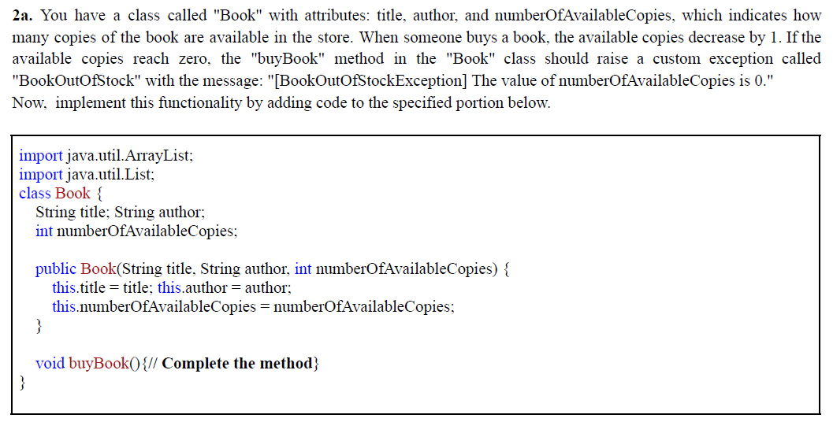
2. 